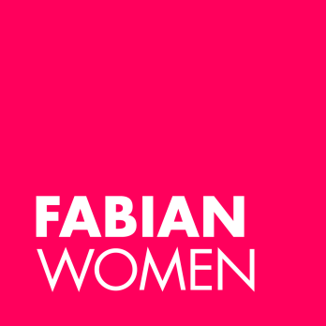

APPLICANTS’ DIVERSITY MONITORING FORM 2024

The Fabian Women’s Network would like to build up a picture of those applying for its Political and Public Life Mentoring Programme. The information will be used as part of the monitoring process. It does not form part of the selection process. The information will be published anonymously as part of an evaluation report. After collation for monitoring this information will not be kept by the Fabian Women’s Network.

Please mark appropriate boxes with X

Age

 | Under 20 |  | 40-49
 | 20-30 |  | 50-59
 | 30-39 |  | 60 +

What is your ethnic group?

Choose ONE section then select the appropriate box to indicate your background.

White

British

English
Scottish
Welsh
Other, please write in

Irish
Any other White background, please write in
____________________________________________________

Mixed

White and Black Caribbean
White and Black African
White and Asian
Any other Mixed background, please write in

___________________________________________________

Asian, Asian British, Asian English, Asian Scottish or Asian Welsh

Indian
Pakistan
Bangladeshi
Any other Asian background, please write in

___________________________________________________

Black, Black British, Black English, Black Scottish or Black Welsh

Caribbean
African
Any other Black background, please write in
___________________________________________________

Chinese, Chinese British, Chinese English, Chinese Scottish or

Chinese Welsh

Chinese
Any other Chinese background, please write in
____________________________________________________

Other

Any other background, please write in
___________________________________________________

Disability

Do you have a disability? Yes |  | No

Thank you for completing this form. Please submit alongside your application and CV to FWNmentoring@fabians.org.uk

